Task : 13 Multi-Factor Authentication

MFA in AWS (Multi-Factor Authentication) adds extra security by requiring two forms of identification: a password and a code from an MFA device. It helps protect your AWS account even if your password is stolen. MFA devices can be apps, hardware tokens, or SMS-based. Enabling MFA is highly recommended to prevent unauthorized access.

Configured MFA :

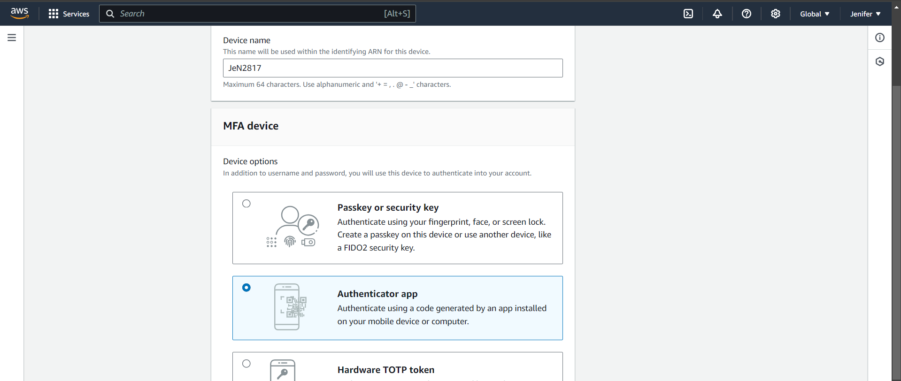

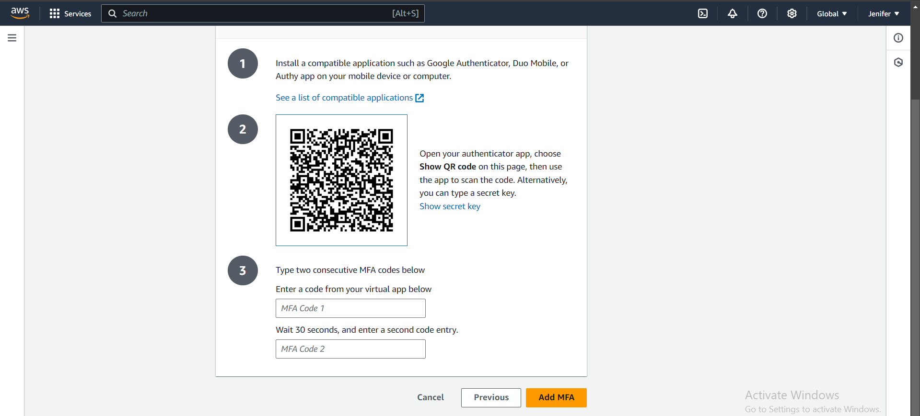

Successfully added MFA in my IAM :

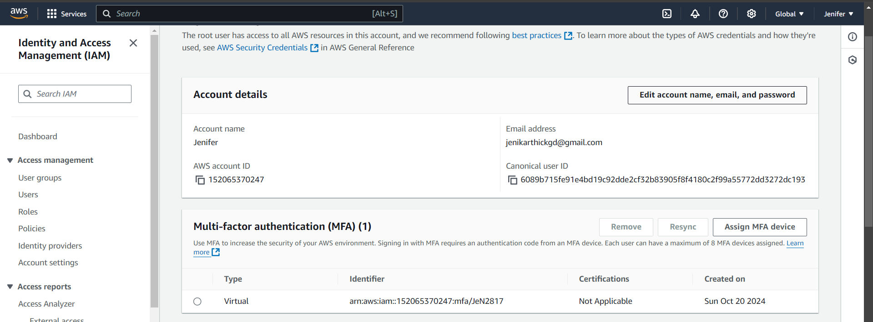

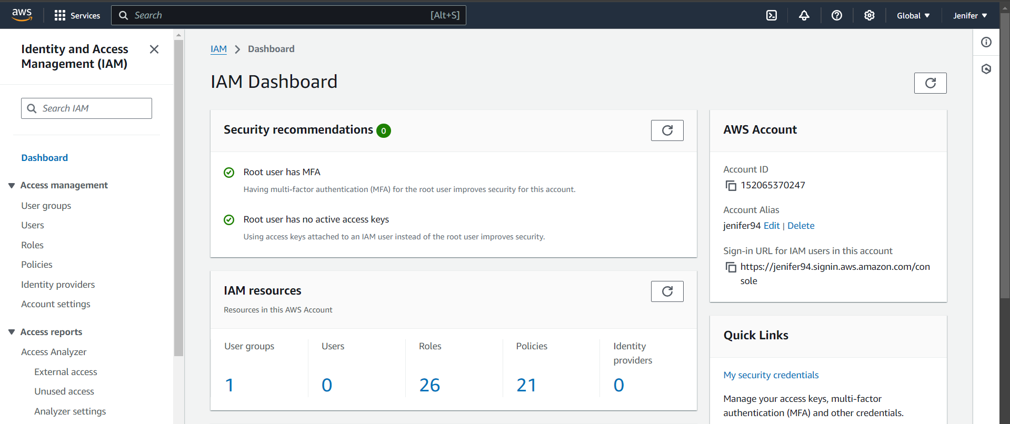

An attempt to remove my MFA, but I have got an error as like below:

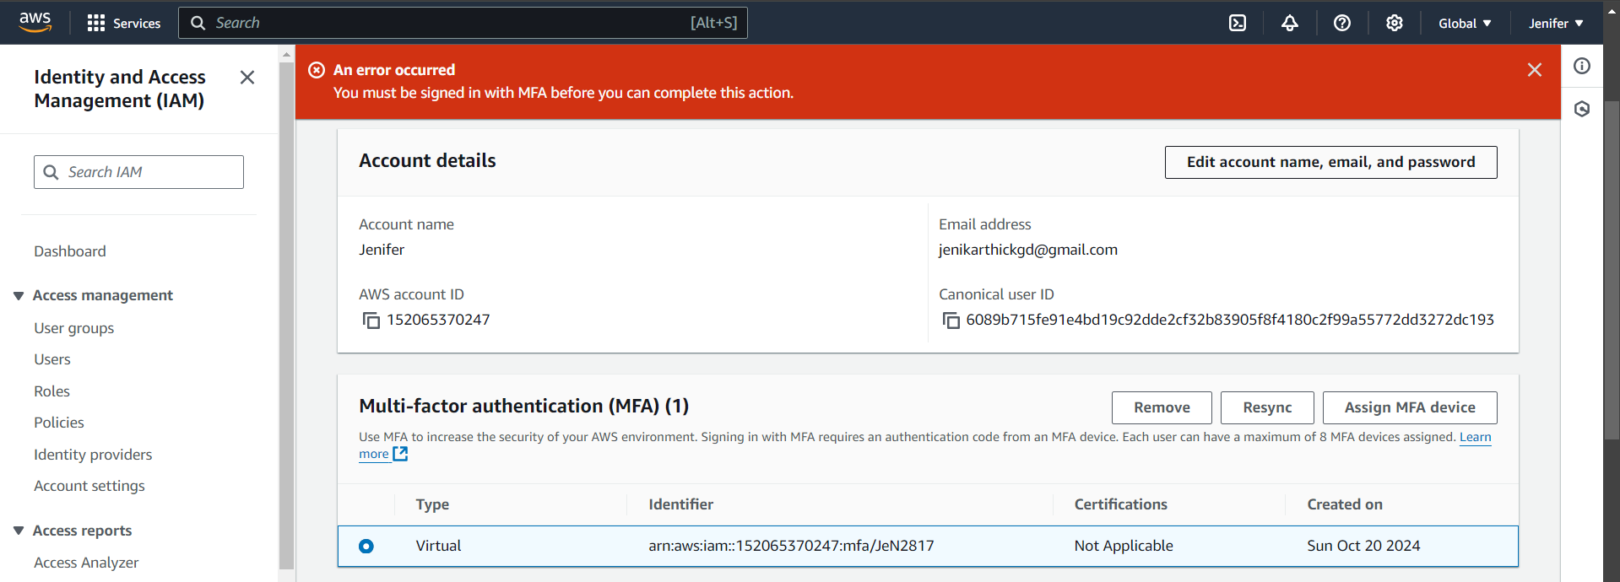

Singing in to my AWS account via MFA :

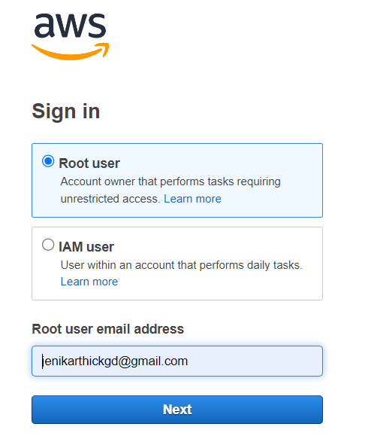

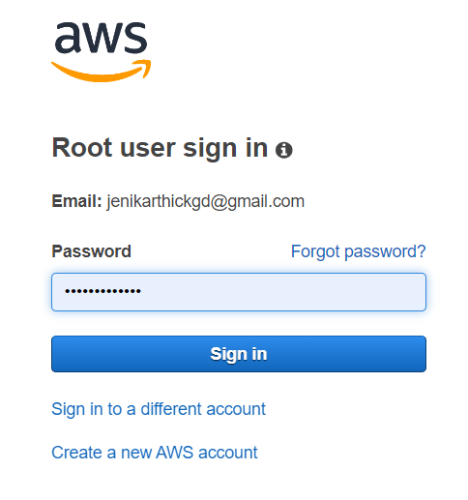

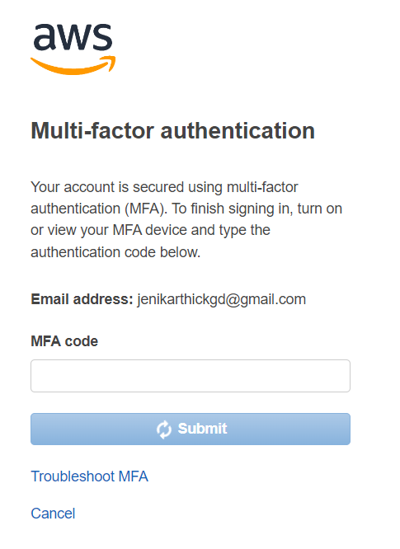

Once I have done with the log in using MFA, I could able to remove the MFA I have created before

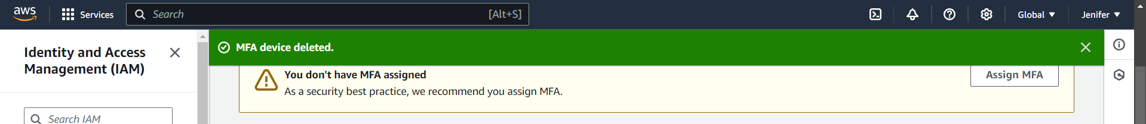

After removing my Multi-Factor Authentication, I have got the mail from AWS team as below:

